modular EW systems
and impact on training
and operations

Agenda
Location: | Hotel Sofitel Alter Wall 40, 20457 Hamburg, Germany | Moderator: Director AOC
Date: | 28. February 2020 | Time: 17:00 – 21:00

Schedule
 | 17:00 – 17:15 | Welcome Reception
 | 17:15 – 17:30 | „Requirements for Flexible Electronic Warfare of the Future - Modularity, Equipment Sustainability, Distributed Systems” | 
 | 17:30 – 18:00 | „Significant dimensions of planning and execution of electronic warfare and impact on conception and architecture of future-proof systems.” | 
 | 18:00 – 18:30 | “Training, Test & Verification” |   
 | 18:30 – 19:00 | „How can the training of soldiers keep pace with the rapid development of technologies and concepts?” | 
 | 19:00 – 19:30 | Panel Discussion / Q&A
 | 19:30 – 21:00 | Dinner

Additional Information
The participants are invited to welcome drinks, meals during the event and dinner together. For travel, accommodation and other costs, each participant must pay himself. If we can be of assistance for your travel / stay, please do not hesitate to contact us: COMPLETER.NET Sales & Engineering GmbH, Tel.: +49 (0)40 55640351
Please flip page for more information
Loacton:
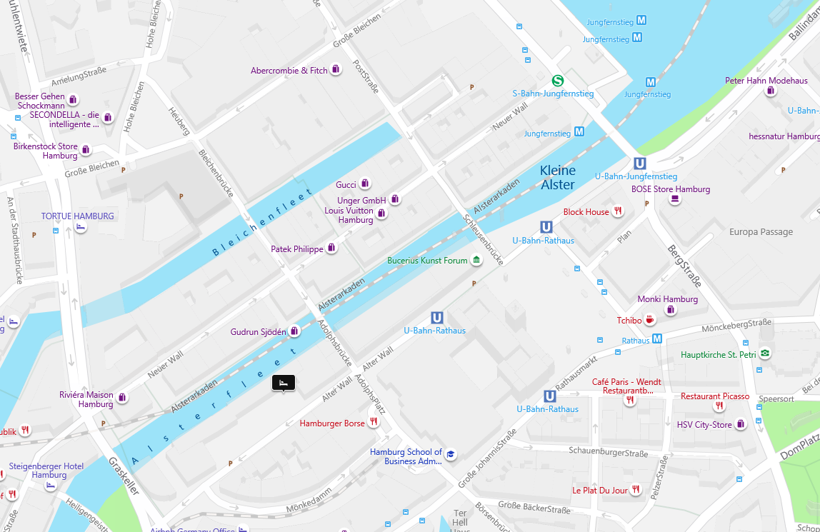
https://binged.it/2QdJlcw
Hotels close by: 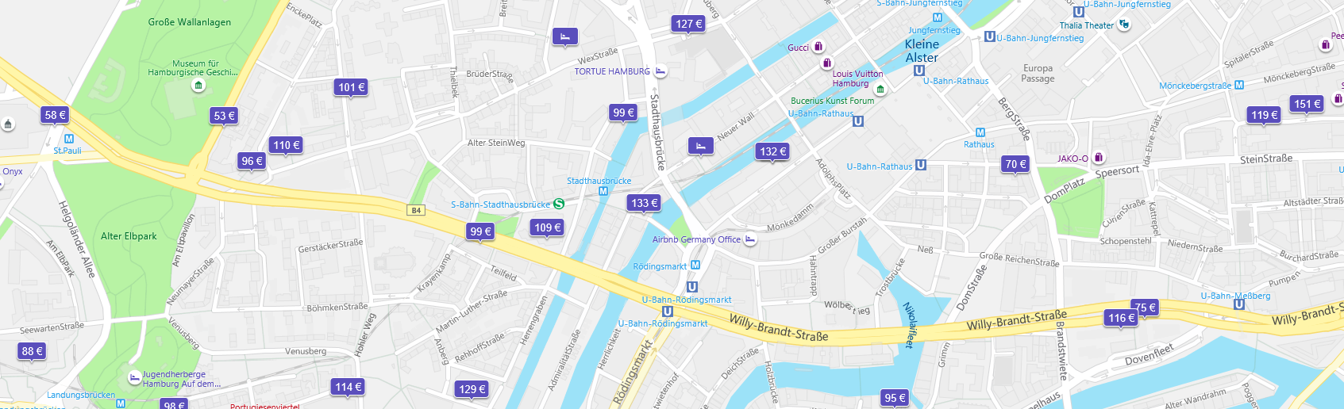https://binged.it/34OQZz9
Events this weekend in Hamburg:
Hamburg Towers Basketball Bundesliga 29.02.2020 https://hhtowers.online-ticket.de/hamburg-towers-hakro-merlins-crailsheim-tickets-129.html
FC St .Pauli 2. Bundesliga 28.02- 02.03 https://www.fcstpauli.com/tickets/heimspiele/
https://www.barclaycard-arena.de/events
https://www.eventim.de/city/hamburg-7/?affiliate=TUG&startdate=2020-02-29&enddate=2020-03-01
Eisbahn Planten un Blomen: https://www.hamburg-tourism.de/sehen-erleben/freizeit-sport/sport-bewegung/eisarena-hamburg/
Hamburg Coffee Festival: https://www.hamburg-coffee-festival.de/

